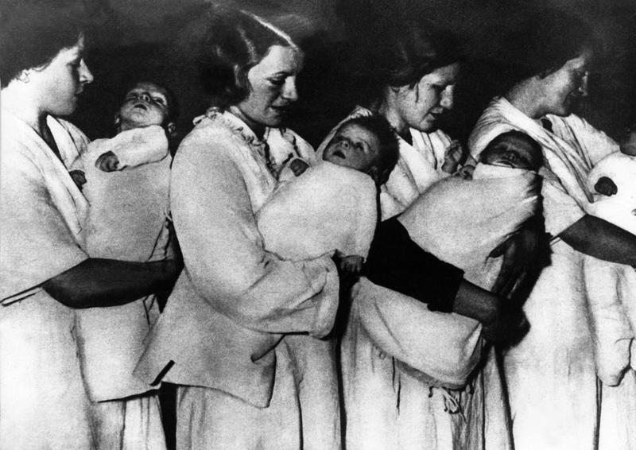

Lebensborn: The Nazi Baby Factory

WORLD HISTORY | November 28, 2018
German Women Carrying Children On An Alleged Aryan Purity In A Lebensborn, Selection Center Births By Methods Eugenicists During The Second World War. (Photo by Keystone-France/Gamma-Keystone via Getty Images)
The ultimate goal of Adolf Hitler and the Nazi Party was to create a superior race of people, the Aryan race, made up of racially pure, healthy, beautiful Germans. To this end, the SS initiated a program known as Lebensborn that, in a sense, became a Nazi baby factory. The Lebensborn, which had the full support of the German government, kidnapped babies and young children, encouraged unwed mothers to birth multiple babies, and sent SS agents to rape beautiful women to produce perfect babies.
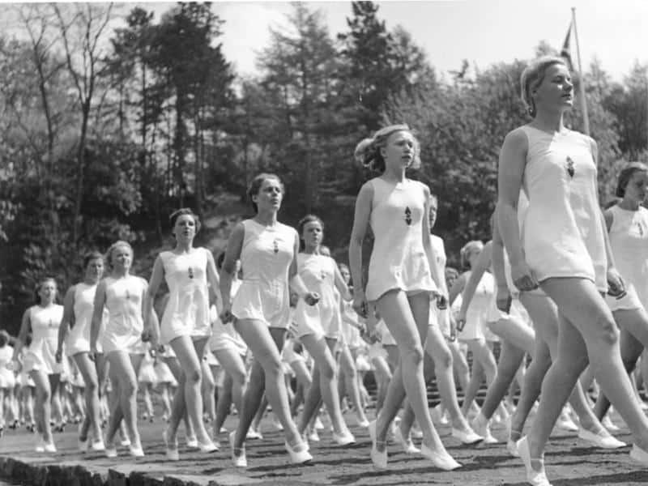

A lot of Babies were Needed to Build a Perfect Race
The Lebensborn program was a way for the government to drastically increase the Aryan birth rate. These so-called ‘perfect’ children, were to grow up and further increase the racial purity of the Germans and spread the beautiful Germanic people to all parts of Europe, for an eventual takeover. The more perfect, blonde people, the better.
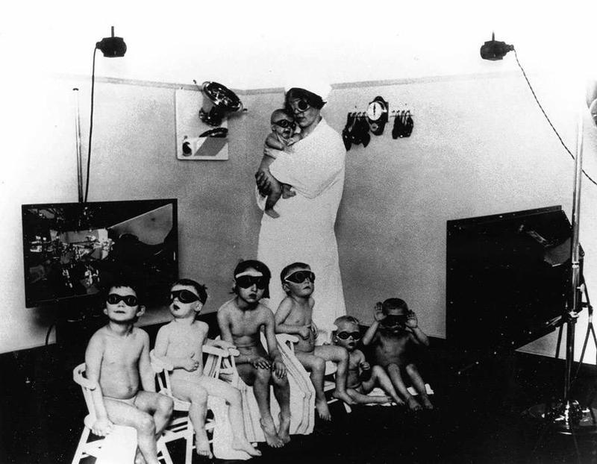

The Lebensborn Program Promoted Unwed Births
The Nazi Lebensborn Program instilled in the minds of young, unmarried women that they would be helping their country by giving birth to as many perfect German babies as they could. To further encourage this baby factory mentality, the SS set up maternity homes and hospitals where unwed young women could go to receive care during pregnancy and delivery. The babies were adopted out to families that were pure, healthy, and loyal to the Nazi Party, most often SS members. In fact, the women were often impregnated by SS soldiers. The League of German Girls organization even recruited young German women who would be good breeding stock. By living at the state-run maternity homes, the women didn’t receive the social stigma that other unwed mothers got.
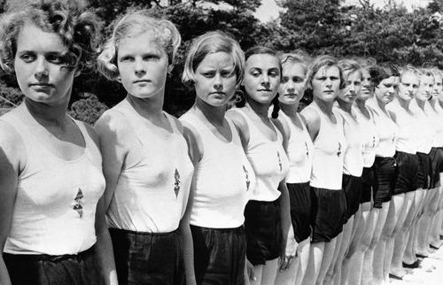

The Lebensborn Kidnapped Children
When the Nazis invaded other European countries, especially ones with Germanic populations, the SS soldiers were instructed to keep their eyes open for young, beautiful babies. Many babies were taken from their parents and given to Lebensborn homes to be raised by the SS. The kidnapped children were chosen on their appearance, as well as the appearance of their parents. The hope was that each child was pure and Aryan, so blonde, beautiful babies with blonde, beautiful parents were viewed as superior. Much of the kidnappings came to light during the Nuremberg Trials.
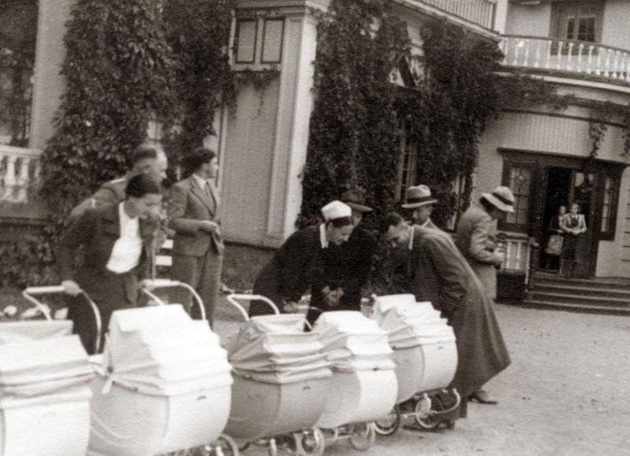

Some Kidnapped Children Became German Citizens…Others Went to Concentration Camps
The SS agents removed children from their parents across Europe. In fact, there is evidence that most of the babies came from Poland and Yugoslavia, but that the other babies were stolen from the Ukraine, Russian, Romania, Norway, and Czechoslovakia. According to the records that were kept by the SS and Lebensborn Program, the kidnapped babies were carefully examined and tested. The ones who were deemed acceptable were given German names and adopted to prominent SS members to be raised as part of their families. The ones who exhibited non-German traits were sent to the Concentration Camps.

